Creating Functions

1. We will start by creating a function DrawSquare associated with Sprite 1 (the cat).
2. Click on MyBlocks

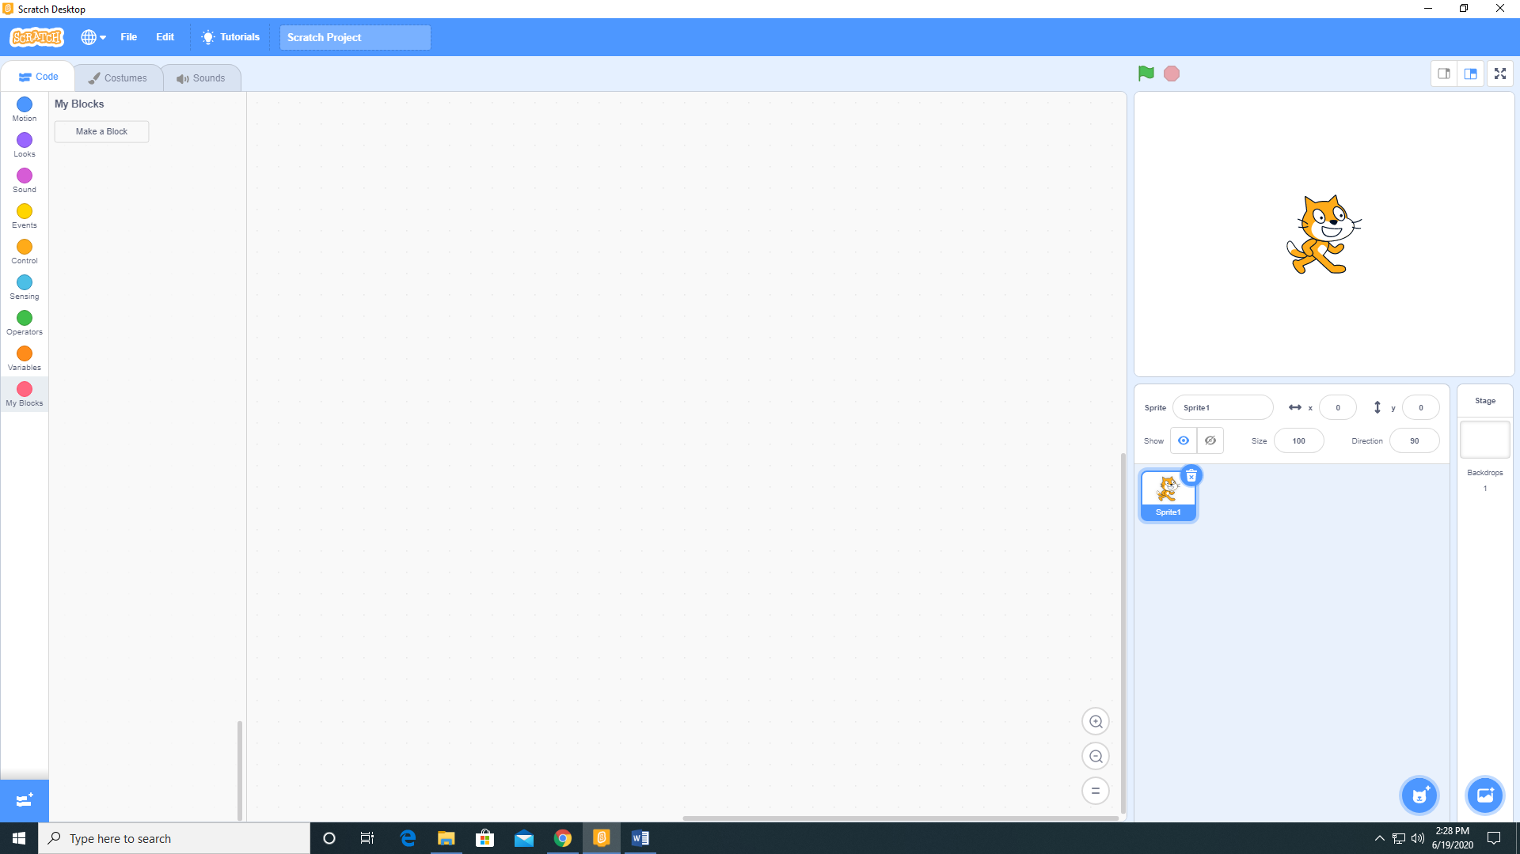

1. Click on Make a Block and the Make a Block window will open. Name it DrawSquare. We are not going to add an input or a label. Click OK.

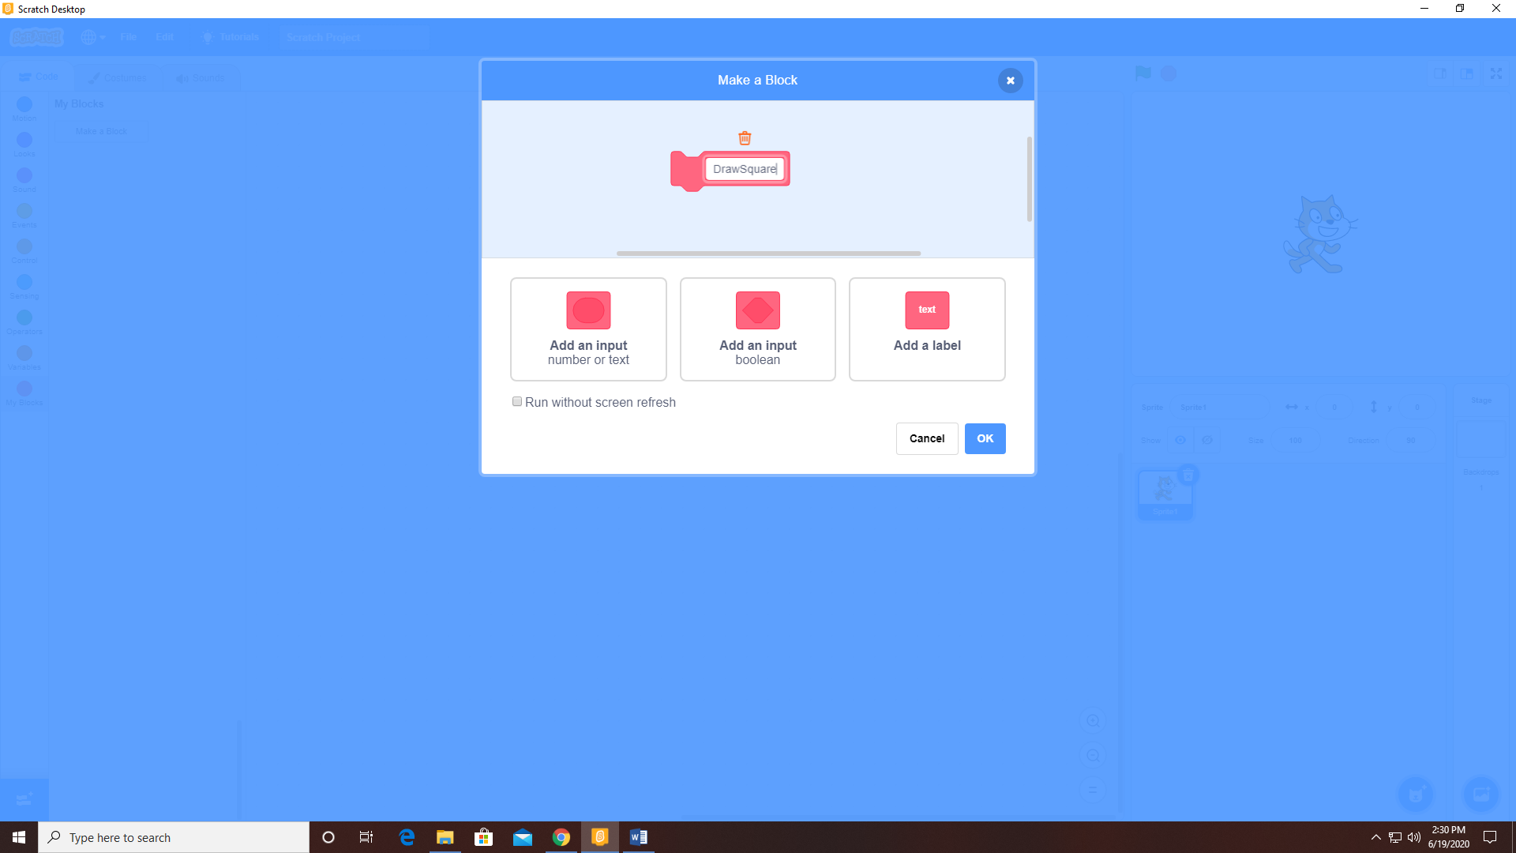

1. We now have a function named DrawSquare. We next need to write the code that defines this function. For this function, I have added the Pen extension.

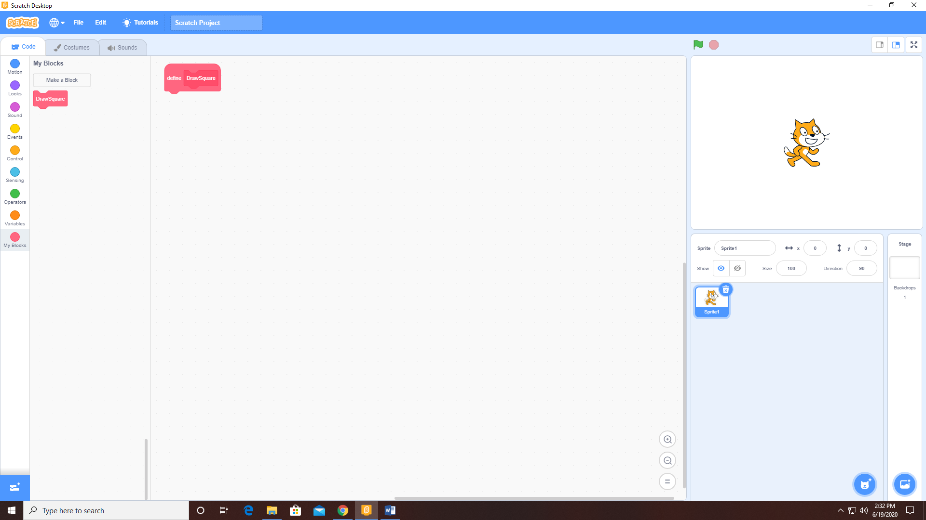

1. Once we have written the function code then all we need to do is call the function.

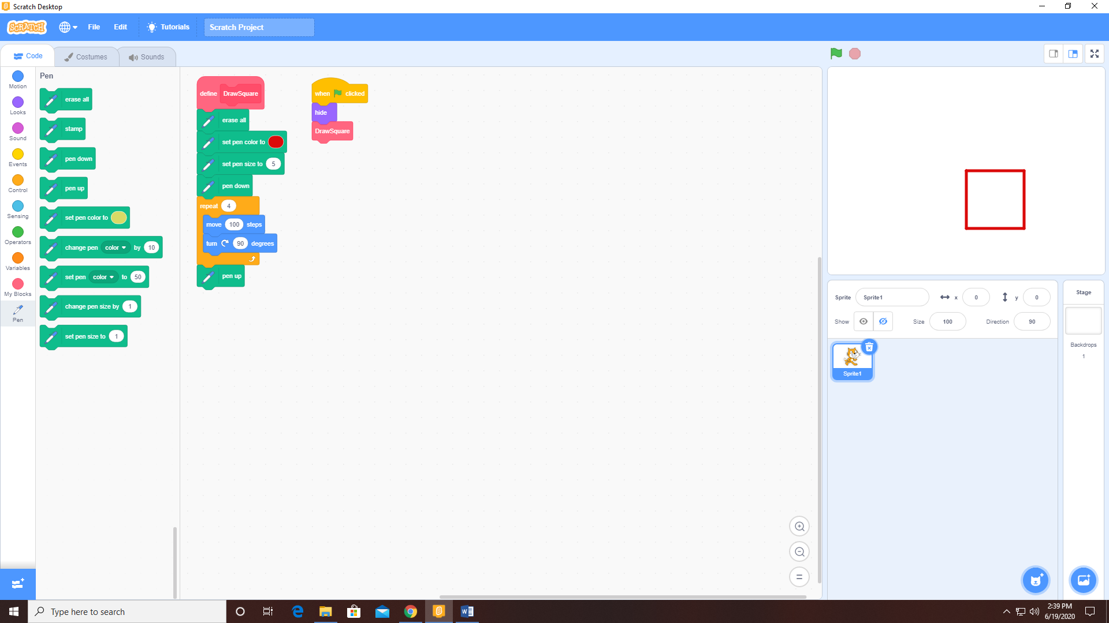

This is the output.



1. Now let’s try creating a function with a parameter (number of sides). The function is named DrawPolygon and it recieves one parameter (number of sides)

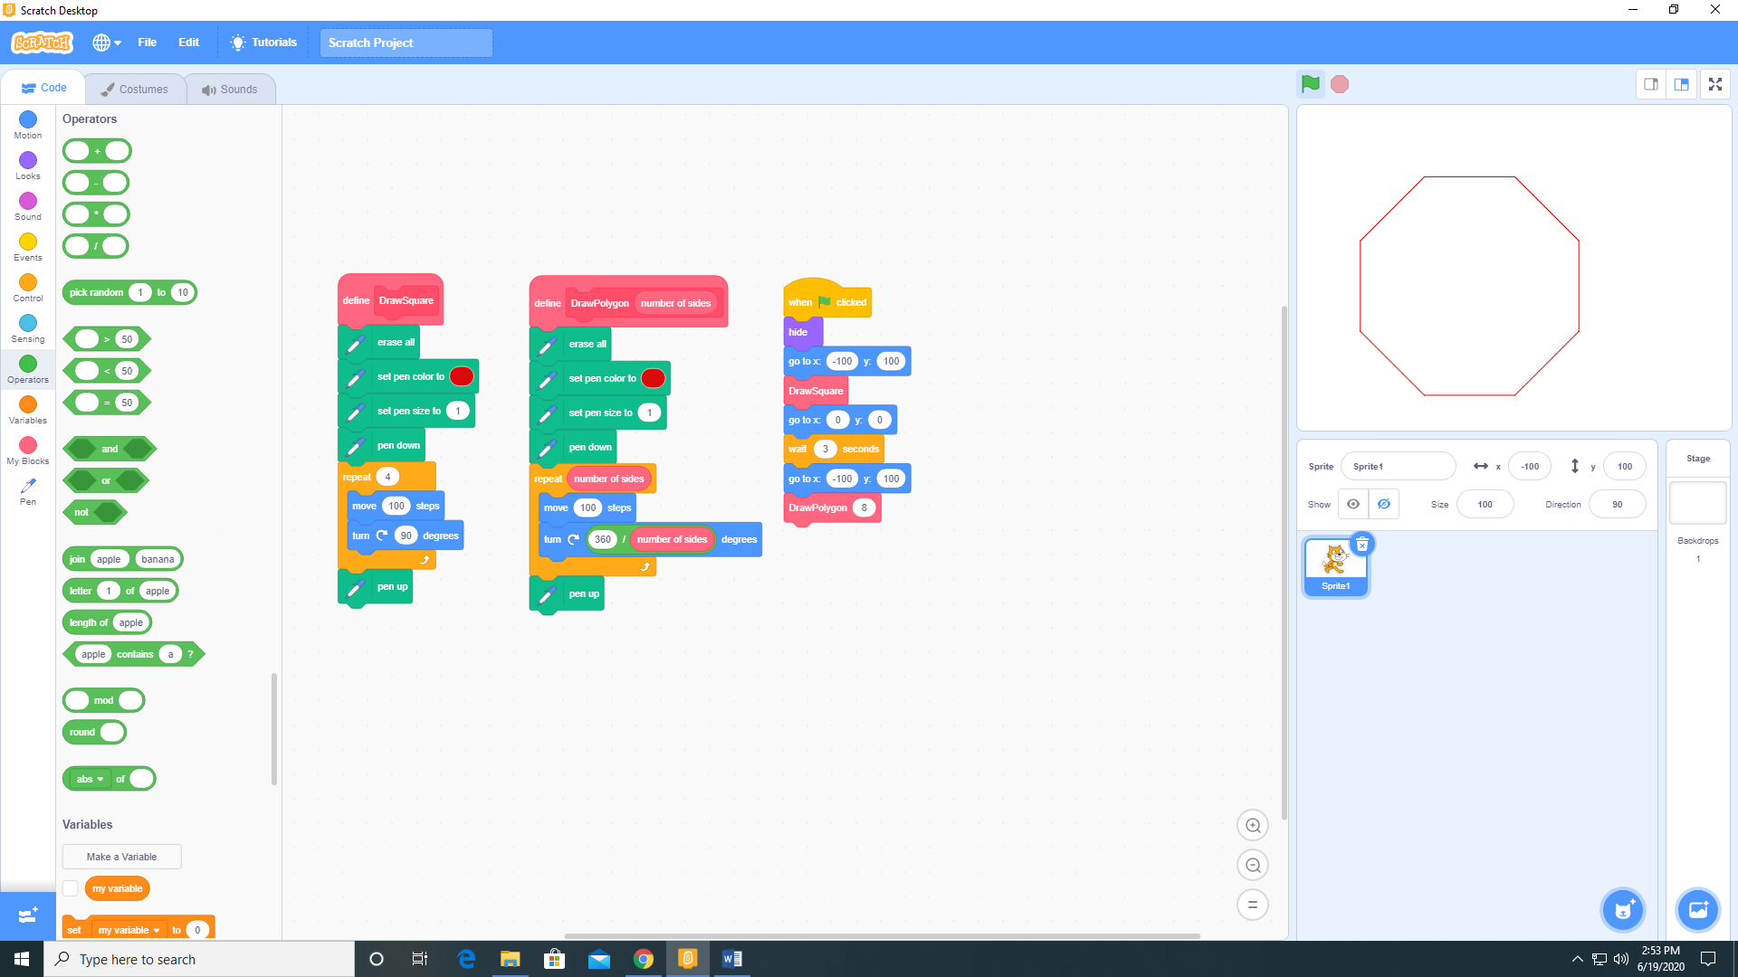

Here is the final output

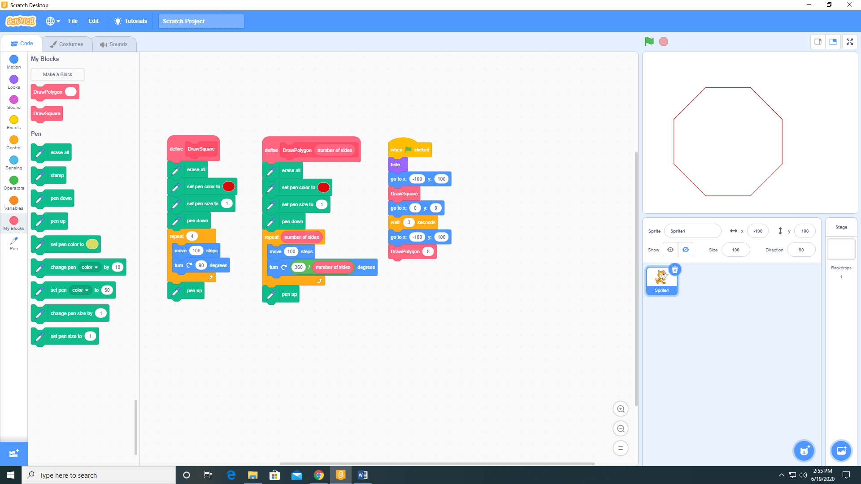

If we wanted a hexagon instead of an octogon we just need to change the code to this.

